First Person All-In-One
Documentation

The purpose of this document is to provide information on the main asset's attributes.

Basic Input: W,A,S,D to move. 'Shift' key to sprint.

Note:
The hierarchy of the player object must be in this order:
Player and Script>Headjoint>Camera

Mouse Rotation Settings
Enable Camera Movement (Bool):
On: Script will register mouse input and apply it to camera rotation.
Off: Script will ignore input from the mouse and the camera will not move when the mouse is moved

Rotation Range (Float):
As exemplified in the graphic below; from center, how much range in degrees
does the camera have to move up and down.
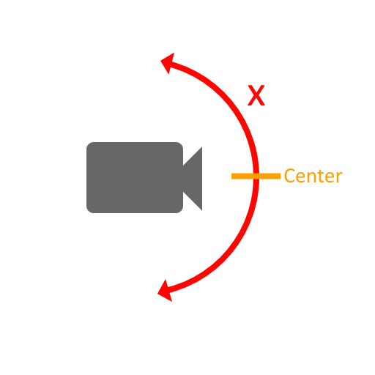

Mouse Sensitivity (Float):
How sensitive is the mouse input? Higher = faster camera movement, Lower = slower camera movement.

Camera Smoothing (Float):
How smoothed should the camera movement be? Higher = super smooth camera movement, lower = super tight camera movement. For shooter games, it is recommended to keep this value low for a better faster feel.

Lock And Hide Cursor (Bool):
Mostly for development use, it is recommended to do this from a GameManager script for you particular project.
On: Hides mouse cursor at runtime, press escape to unlock cursor.
Off: Leaves cursor viable and unlocked at runtime.

Player Camera (GameObject):
Camera attached to the Head-joint on the Player object.

Enable Camera Shake( Bool):
On: Allow access to the “CameraShake” co-routine (Page 8)
Off: No access to the “CameraShake” co-routine is given.

Auto Cross-hair (Bool):
Once again, recommended for development use.
On: Script will automatically create and position necessary GameObjects to make a proper cross-hair.
Off: No cross-hair will be generated by the script.

Cross-hair (Float):
Sprite to use as cross-hair.

Movement Settings

Player Can Move (Bool):
On: Script will register keyboard input and move player.
Off: Script will ignore keyboard input.

Walk By Default (Bool):
Toggles what happens when you press the shift key
On: Player moves at walking speed when not holding shift, then moves at sprinting speed when 'Shift' is held.
Off: Player moves at sprinting speed when not holding shift, then moves at walking speed when 'Shift' is held.

Walking speed (Float):
How fast the player will move in the walking state.

Sprinting speed (Float):
How fast the player will move in the sprinting state.

Jump power (Float):
How much upward force gets applied to the Ridgedbody when space is pressed.

Can Hold Jump (Bool);
On: When space is held, player will automatically jump every time the collider hits the ground
Off: User must press space every time they wish to jump when on the ground.

Use Stamina (Bool):
On: The script will apply the stamina system to walking/sprinting.
Off: Player can remain in sprinting state with no time limitation.

Stamina Depletion Speed (Float):
How fast the player runs out of stamina when sprinting. Stamina will also be gained back when player is not in the sprinting state at half this rate.

Stamina (Float):
The max amount of stamina the player can have.

Movement Settings - Crouch Modifiers:

Use Crouch (Bool):
On: With proper input, the player can change size, speed, and jump power while in the crouching state.

Crouch Input Axis(String):
This is the name of the axis you wish to control the crouching state.

Walk Speed While Crouching (Float):
How fast the player will move while in the couching state.

Sprinting Speed While Crouching (Float):
Often equal to the above value, This is how fast the player will move while crouching and holding 'Shift' at the same time.

Jump Power While Crouching (Float):
How high – if at all – the player can jump while in the couching state.

Movement Settings – FOV Kick:

Use FOV Kick (Bool):
On: The script will change the field of vision (FOV) when the player starts sprinting
Off: The script won't change the FOV at runtime.

FOV Kick Amount (Float):
How much the script will change the camera's FOV.

Change Time (Float):
How fast the script will smoothly change the camera's FOV.

Kick Curve (Animation Curve):
The curve the FOV change will take.

Movement Settings – Advanced

Gravity Multiplier (Float):
How much should the physics engine's gravity force be multiplied and applied to the player's ridgedbody? Higher than 1 means more gravitational force, lower than 1 means less gravitational force. 1 = no change to the engine's set gravitational force.

Zero Friction Material (Physics Material):
For smooth movement, use a physics material with the friction value set to zero.
High Friction Material (Physics Material):
When no movement input is given, this material is applied to make sure the player won't move or slide. Use a physics material with the friction value set to max.
If some movement is desired, lower the material's friction value until you find a value that fits your project.

Use Slope Detection (Bool):
On: The script will detect the angle of the platform the player is standing on.
If the angle of the platform exceeds the “Max Slope Angle” as described below,
the script will attempt to keep the player from walking up the slope.
Off: The script will allow the player to walk up slopes up to 89 degrees.

Max Slope Angle (float):
The max angle a slope can be before the script will attempt to keep the player from walking up said slope.

Head-bobbing Settings

Use Head-bobbing settings (Bool):
On: The script will apply head-bobbing animations to the head-joint.
Off: The script won't apply animations to the head-joint, but will still run the calculations needed to do so, as the Dynamic foot step SFX process (Page 8)
needs the same calculation data.

Head-joint (Transform):
This is the transform parent of the camera.

Head-bob Frequency (Float):
The frequency in which the head-joint will change direction in the head-bob animation.

Head-bob Sway Angle (Float):
Angle of the sway from side to side in the head-bob animation.

Head-bob Height (Float):
The highest point in the animation.

Use Jump Land Movement (Bool):
On: The script will animate a head jolt when the player jumps or lands.
Off: Jumping and landing will not have any animations.

Jump Angle (Float):
This is how much, in degrees, the head-joint will turn upwards when the player jumps.

Land Angle (Float):
This is how much, in degrees, the head-joint will jolt downwards when the player hits the ground.

Audio/SFX Settings

Volume (Float):
Volume at which SFX will be played.

Jump sound (Audio Clip):
Audio clip that will play when the player jumps. Leave empty for no sound or if you're using Dynamic Foot steps.

Land Sound (Audio Clip):
Audio clip that will play when the player lands on the ground. Leave empty for no sound or if you're using Dynamic Foot steps.

Use Foot Step Sounds (Bool):
On: The script will choose an audio clip at random from the array below, and play it when a full step is taken (calculated with Headbob Frequency value above)
Off: No foot steps will be played.

Foot Step Sounds (Array):
This will also act as a fall back sound pool for Dynamic Foot steps.
Size: how many foot step sounds are available to the script to choose from

Audio/SFX Settings – Dynamic Foot Steps
The dynamic foot step process allows certain ground objects to trigger different sounds. E.g. A box with a physics material assigned as “Wood” in the below material slots, will trigger whatever Audio clips you put in the “Wood Footsteps” array.

For this section, we will use the “Wood” and “Wood Footsteps” to explain how the system works. However, the process is the same for all other six footstep variants.

Use Dynamic Foot step Process (Bool):
On: The script will detect what physics material the Player is standing on and play a corresponding sound each full step. If the material is not recognized, the script will fall back to the “Foot Step Sounds” array.
Off: The script will only use the “Foot Step Sounds” array.

Wood (Physics Material):
When the script detects that the collider the player is standing on has this physics material, it will only play foot step sounds from the “Wood Footsteps” Array below. Apply this physics material to anything you want to act as a trigger for the
“Wood Footsteps”

Wood Footsteps (Array):
Footstep sounds that will play when the script detects that the player is standing on a collider with the above “Wood” Physics material.
Size: how many foot step sounds are available to the script to choose from

Internal Functions

CameraShake (IEnumerator):
For a cinematic camera shake effect, Call this as a co-routine from a something like a GameManager or LevelManager script.

Overloads:
Duration (Float): How long in seconds, will the camera shake event last.
Magnitude (Float): How much the camera will shake.

